**TYPING TESTER**

Introduction:  
 The Typing Tester is a Python-based application designed for users to practice and improve their typing skills. It measures the typing speed in words per minute and the accuracy of typing. This document provides a detailed explanation of the libraries and functions used in the project, making it easy for students to understand.

Libraries and Modules:  
 1. time module: This is a built-in Python module used to work with time-related tasks. In our project, we use it to record the time at which the user starts and finishes typing, which helps in calculating the typing speed.

Functions and Code Explanation:  
 1. calculate_speed_and_accuracy function:  
 - Purpose: To calculate the user's typing speed and accuracy.  
 - Parameters: user_input (the text typed by the user), start_time (time when typing starts), end_time (time when typing ends).  
 - How it works: The function counts the number of words typed and calculates the time taken. It then computes the typing speed (words per minute) and accuracy (percentage of correct characters typed).  
  
 2. typing_test function:  
 - Purpose: To conduct the typing test by interacting with the user.  
 - How it works: This function displays the test text, waits for the user to start typing, captures the typed input, and then calls calculate_speed_and_accuracy to compute the results. Finally, it displays the typing speed and accuracy.

Some snippets of my program outputs are as follows:

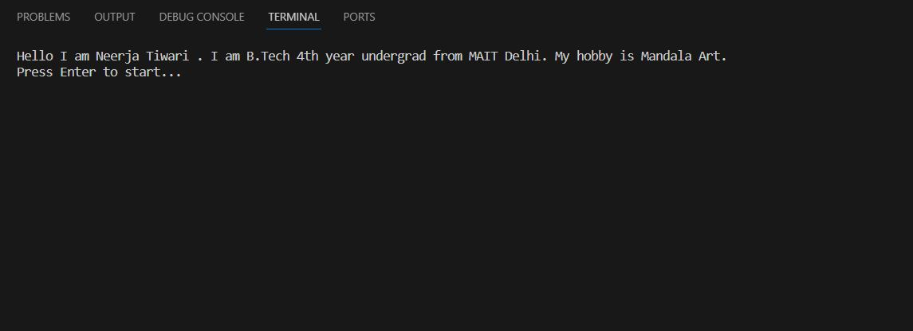

Fig 1

After we press enter,   
 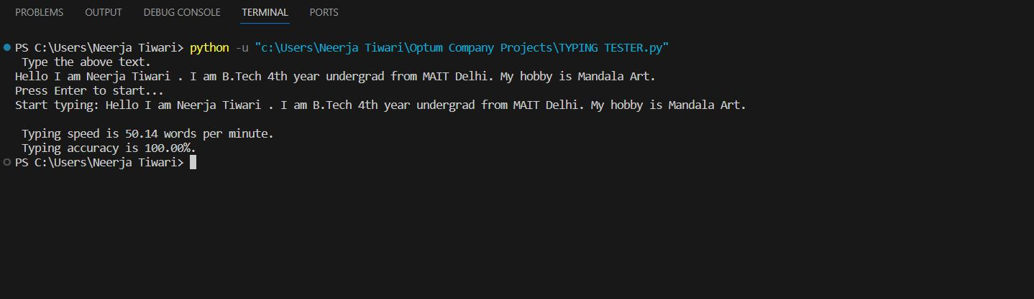

Fig 2

Which finally displays the “Typing Speed” and “Typing Accuracy” of a user’s speed when he/she writes the text.

Conclusion:  
 The Typing Tester project is a practical tool for improving typing skills, especially for beginners. The code is straightforward and serves as a great example for students learning Python and basic programming concepts.